Kendall Sisk

October 2020

Three Observable Trends in Heroes of Pymoli Data

1. In the below summary table on age demographics, I had to look at what age group most of the players from the data, fell into. You can see that most players were in the 20-24 year old age range. They made up 44.79% of the data with a total of 258 players. The group with the least amount of players fell into the 40+ year old age range. They only had 12 players with a percentage of 2.08% of the data. While it’s not surprising to me that the oldest group had the least amount of players due to probably having careers and families, I was surprised to see that the highest group was not in the 10-14 year old age range. I would have thought their numbers would have been higher than only 3.82% of the data.

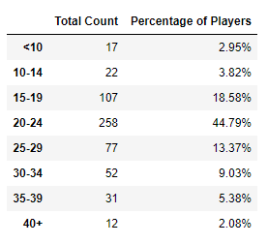

1. In the below summary table on gender demographics, I had to look at what gender group most of the players from the data, fell into. You can see that 84.03 % of the data (a total of 484 players) were male players, showing that much more males play video games than females do. The company should continue to target males as their number one player but look to how they could possibly get more females involved.

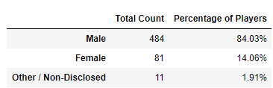

1. In the below summary table on gender demographics, I had to look at who the top spenders were from the data provided. You can see the 5 top spenders based on the total purchase value. While it mentioned that the game was free to play, they encouraged optional items for players’ gaming experience. It appears that “Lisosia93” did just that. They made 5 extra purchases, averaging $3.79 for each purchase they made, and spent a total of $18.96 to enhance their experience. Player “Idastidru52” was not far behind with 4 extra purchases, averaging $3.86 for each purchase they made. They spent a total of $15.45 to enhance their experience. While the game is free, players are still spending money which means good things for this gaming company.

